Aim: To develop a Hotel Room Booking System using HTML, CSS, and JavaScript that enables users to explore hotel rooms, view room details, enter booking information, and receive booking confirmation through an interactive webpage.
Algorithm:
- Start the program and display the hotel home page.
- Show the available room types, images, facilities, and prices.
- Allow users to select a room and enter check-in and check-out dates.
- Collect customer details and the number of guests.
- Validate the booking information using JavaScript.
- Calculate or display the estimated room cost.
- Display a booking confirmation message after successful validation.
- Stop the program.
Program:
<!DOCTYPE html>
<html lang="en">
<head>
<meta charset="UTF-8">
<meta name="viewport" content="width=device-width, initial-scale=1.0">
<title>Stayora | Hotel Booking</title>

<style>
* {
margin: 0;
padding: 0;
box-sizing: border-box;
}
body {
font-family: "Segoe UI", Arial, sans-serif;
background: #f8f7f3;
color: #24332d;
}
header {
display: flex;
justify-content: space-between;
align-items: center;
padding: 22px 7%;
background: white;
border-bottom: 1px solid #e9e7df;
}
.logo {
font-family: Georgia, serif;
font-size: 29px;
font-weight: bold;
color: #244b3e;
}
.logo span { color: #c69b59; }
nav a {
text-decoration: none;
color: #43554c;
margin-left: 25px;
font-size: 14px;
}
nav a:hover { color: #c69b59; }
.hero {
min-height: 390px;
padding: 75px 7% 115px;
background:
linear-gradient(90deg, #142e28ed, #142e2888, #142e2820),
url("https://images.unsplash.com/photo-1571896349842-33c89424de2d?auto=format&fit=crop&w=1800&q=85")
center/cover;
color: white;
}
.hero small {
color: #e8cb94;
letter-spacing: 3px;
text-transform: uppercase;
}
.hero h1 {
font-family: Georgia, serif;
font-size: clamp(38px, 5vw, 62px);
max-width: 620px;
line-height: 1.13;
margin: 20px 0;
}
.hero p {
max-width: 480px;
line-height: 1.8;
color: #e9eee9;
}
.search-panel {
position: relative;
max-width: 1100px;
margin: -55px auto 45px;
padding: 24px;
background: white;
border-radius: 14px;
box-shadow: 0 12px 40px #23392d15;
display: grid;
grid-template-columns: 1.4fr 1fr 1fr .8fr auto;
gap: 15px;
align-items: end;
}
.field label {
display: block;
color: #778078;
font-size: 12px;
margin-bottom: 9px;
}
input, select {
width: 100%;
padding: 12px;
border: 1px solid #e2e6df;
background: #fcfcfa;
border-radius: 7px;
font: inherit;
color: #263b31;
min-width: 0;
}
button {
border: none;
cursor: pointer;
border-radius: 7px;
font-weight: 600;
transition: .2s;
}
button:hover { opacity: .85; transform: translateY(-1px); }
.search-btn {
background: #244b3e;
color: white;
padding: 14px 20px;
}
.container {
max-width: 1200px;
margin: 0 auto;
padding: 0 25px 50px;
}
.section-top {
display: flex;
justify-content: space-between;
align-items: end;
gap: 15px;
margin-bottom: 25px;
}
.eyebrow {
color: #b18343;
text-transform: uppercase;
letter-spacing: 2px;
font-size: 12px;
font-weight: bold;
}
h2 {
font-family: Georgia, serif;
font-size: 34px;
font-weight: 500;
margin-top: 8px;
}
.section-top p {
color: #7b837c;
font-size: 14px;
margin-top: 10px;
}
.room-grid {
display: grid;
grid-template-columns: repeat(3, minmax(0,1fr));
gap: 25px;
}
.room-card {
background: white;
border-radius: 13px;
overflow: hidden;
box-shadow: 0 6px 25px #25372d0b;
transition: .25s;
}
.room-card:hover {
transform: translateY(-5px);
box-shadow: 0 12px 35px #25372d18;
}
.room-img {
height: 225px;
position: relative;
background: #e4e4dc;
}
.room-img img {
width: 100%;
height: 100%;
object-fit: cover;
}
.tag {
position: absolute;
top: 15px;
left: 15px;
background: #fff;
padding: 7px 11px;
font-size: 11px;
border-radius: 5px;
font-weight: bold;
}
.room-info { padding: 21px; }
.room-info h3 {
font-family: Georgia, serif;
font-size: 23px;
font-weight: 500;
}
.location {
color: #838a83;
font-size: 13px;
margin: 9px 0 17px;
}
.amenities {
display: flex;
flex-wrap: wrap;
gap: 13px;
color: #66736a;
font-size: 12px;
padding-bottom: 18px;
border-bottom: 1px solid #eeeee8;
}
.price-row {
display: flex;
justify-content: space-between;
align-items: center;
margin-top: 18px;
gap: 10px;
}
.price {
font-size: 23px;
font-weight: bold;
color: #244b3e;
}
.price small {
font-size: 11px;
color: #858b84;
font-weight: normal;
}
.book-btn {
padding: 12px 16px;
background: #244b3e;
color: white;
}
.empty {
display: none;
text-align: center;
background: white;
padding: 35px;
border-radius: 12px;
color: #778078;
}
.benefits {
display: grid;
grid-template-columns: repeat(3,1fr);
gap: 20px;
margin: 35px 0;
}
.benefit {
background: #eeefe7;
padding: 24px;
border-radius: 10px;
}
.benefit b { display: block; margin-bottom: 8px; }
.benefit p { color: #737d72; font-size: 13px; line-height: 1.6; }
footer {
background: #19392f;
color: white;
padding: 35px 7%;
text-align: center;
line-height: 1.9;
}
footer p { color: #c4d0c7; font-size: 13px; }
dialog {
border: none;
border-radius: 16px;
padding: 30px;
width: min(470px, calc(100% - 28px));
margin: auto;
box-shadow: 0 20px 80px #0004;
}
dialog::backdrop { background: #10241ebd; }
dialog h2 { font-size: 29px; margin-bottom: 12px; }
dialog p { color: #6f786f; line-height: 1.7; margin: 10px 0; }
dialog label {
display: block;
font-size: 13px;
margin: 12px 0 7px;
}
.dialog-actions {
display: flex;
gap: 10px;
margin-top: 18px;
}
.dialog-actions button { flex: 1; padding: 13px; }
.confirm { background: #244b3e; color: white; }
.cancel { background: #e9ece6; color: #293c32; }
#confirmation { color: #26704f; font-weight: bold; }
@media(max-width:950px) {
.search-panel { margin: -45px 20px 40px; grid-template-columns: repeat(2,1fr); }
.room-grid { grid-template-columns: repeat(2,minmax(0,1fr)); }
}
@media(max-width:600px) {
header { padding: 18px; }
nav a { margin-left: 10px; font-size: 12px; }
nav a:nth-child(2), nav a:nth-child(3) { display: none; }
.hero { padding: 55px 22px 85px; }
.search-panel { grid-template-columns: 1fr; margin: -45px 14px 35px; padding: 18px; }
.container { padding: 0 15px 35px; }
.room-grid, .benefits { grid-template-columns: 1fr; }
.section-top { align-items: start; flex-direction: column; }
h2 { font-size: 29px; }
}
</style>
</head>

<body>

<header>
<div class="logo">stay<span>ora.</span></div>
<nav>
<a href="#rooms">Our Rooms</a>
<a href="#benefits">Experiences</a>
<a href="#footer">Contact</a>
</nav>
</header>

<section class="hero">
<small>YOUR NEXT ESCAPE BEGINS HERE</small>
<h1>Stay somewhere<br>extraordinary.</h1>
<p>Beautiful spaces, thoughtful comfort, and memorable moments.
Find the perfect room for your next getaway.</p>
</section>

<section class="search-panel">
<div class="field">
<label for="destination">DESTINATION</label>
<select id="destination">
<option value="all">All destinations</option>
<option value="Goa">Goa</option>
<option value="Jaipur">Jaipur</option>
<option value="Kerala">Kerala</option>
</select>
</div>
<div class="field">
<label for="checkin">CHECK IN</label>
<input type="date" id="checkin">
</div>
<div class="field">
<label for="checkout">CHECK OUT</label>
<input type="date" id="checkout">
</div>
<div class="field">
<label for="guests">GUESTS</label>
<select id="guests">
<option value="1">1 Guest</option>
<option value="2" selected>2 Guests</option>
<option value="3">3 Guests</option>
<option value="4">4 Guests</option>
</select>
</div>
<button class="search-btn" onclick="searchRooms()">Search Stays →</button>
</section>

<main class="container" id="rooms">
<div class="section-top">
<div>
<div class="eyebrow">CURATED FOR YOU</div>
<h2>Find your perfect stay</h2>
<p>Handpicked rooms for every kind of traveller.</p>
</div>
<p id="roomCount">3 beautiful stays</p>
</div>

<div class="room-grid" id="roomGrid"></div>
<div class="empty" id="empty">No rooms match your search. Try another destination.</div>

<section class="benefits" id="benefits">
<div class="benefit">
<b>✦ Thoughtful Comfort</b>
<p>Beautiful rooms designed to make you feel at home, wherever you go.</p>
</div>
<div class="benefit">
<b>♧ Flexible Planning</b>
<p>Choose your dates and guests before confirming your stay.</p>
</div>
<div class="benefit">
<b>♡ Memorable Moments</b>
<p>Find spaces that turn ordinary trips into special memories.</p>
</div>
</section>
</main>

<footer id="footer">
<h2>stayora.</h2>
<p>Your comfort. Your journey. Your story.</p>
<p>© 2026 Stayora Hotel Booking Demo</p>
</footer>

<dialog id="bookingDialog">
<div class="eyebrow">YOUR GETAWAY</div>
<h2 id="dialogTitle">Book your stay</h2>
<p id="dialogDetails"></p>

<label for="customerName">Full Name</label>
<input id="customerName" placeholder="Enter your name" maxlength="100" style="width:100%">

<label for="customerEmail">Email Address</label>
<input id="customerEmail" type="email" placeholder="you@example.com" maxlength="150" style="width:100%">

<p id="priceDetails"></p>
<p id="confirmation"></p>

<div class="dialog-actions">
<button class="cancel" onclick="bookingDialog.close()">Cancel</button>
<button class="confirm" id="confirmBtn" onclick="confirmBooking()">Confirm Booking</button>
</div>
</dialog>

<script>
const rooms = [
{
id:1, name:"Ocean Breeze Suite", destination:"Goa",
location:"Candolim, Goa", price:4500, capacity:3,
image:"https://images.unsplash.com/photo-1611892440504-42a792e24d32?auto=format&fit=crop&w=900&q=80",
tag:"POPULAR CHOICE", amenities:["🛏 King Bed","🌊 Ocean View","❄ AC"]
},
{
id:2, name:"Royal Heritage Room", destination:"Jaipur",
location:"Pink City, Jaipur", price:3200, capacity:2,
image:"https://images.unsplash.com/photo-1618773928121-c32242e63f39?auto=format&fit=crop&w=900&q=80",
tag:"CULTURAL ESCAPE", amenities:["🛏 Queen Bed","🏛 Heritage","📶 Wi-Fi"]
},
{
id:3, name:"Tropical Garden Villa", destination:"Kerala",
location:"Munnar, Kerala", price:5800, capacity:4,
image:"https://images.unsplash.com/photo-1582719508461-905c673771fd?auto=format&fit=crop&w=900&q=80",
tag:"PREMIUM STAY", amenities:["🛏 King Bed","🌿 Garden","🏊 Pool"]
}
];

let selectedRoom = null;
let lastBooking = null;

const bookingDialog = document.getElementById("bookingDialog");
const checkin = document.getElementById("checkin");
const checkout = document.getElementById("checkout");

function localDateString(date) {
const y = date.getFullYear();
const m = String(date.getMonth()+1).padStart(2,"0");
const d = String(date.getDate()).padStart(2,"0");
return `${y}-${m}-${d}`;
}

const today = new Date();
checkin.min = localDateString(today);
checkin.value = localDateString(today);

const tomorrow = new Date(today);
tomorrow.setDate(tomorrow.getDate()+1);
checkout.min = localDateString(tomorrow);
checkout.value = localDateString(tomorrow);

checkin.addEventListener("change", () => {
const date = new Date(checkin.value+"T12:00:00");
date.setDate(date.getDate()+1);
checkout.min = localDateString(date);
if (!checkout.value || checkout.value <= checkin.value) {
checkout.value = checkout.min;
}
});

function renderRooms(list = rooms) {
const grid = document.getElementById("roomGrid");
grid.replaceChildren();

list.forEach(room => {
const card = document.createElement("article");
card.className = "room-card";

const imageWrap = document.createElement("div");
imageWrap.className = "room-img";

const img = document.createElement("img");
img.src = room.image;
img.alt = room.name;
img.loading = "lazy";
img.onerror = () => {
imageWrap.style.background = "#dce5dc";
img.style.display = "none";
};

const tag = document.createElement("span");
tag.className = "tag";
tag.textContent = room.tag;
imageWrap.append(img,tag);

const info = document.createElement("div");
info.className = "room-info";

const title = document.createElement("h3");
title.textContent = room.name;

const location = document.createElement("p");
location.className = "location";
location.textContent = "⌖ " + room.location;

const amenities = document.createElement("div");
amenities.className = "amenities";
room.amenities.forEach(item => {
const span = document.createElement("span");
span.textContent = item;
amenities.appendChild(span);
});

const priceRow = document.createElement("div");
priceRow.className = "price-row";

const price = document.createElement("div");
price.className = "price";
price.textContent = "₹" + room.price.toLocaleString("en-IN");

const small = document.createElement("small");
small.textContent = " / night";
price.appendChild(small);

const button = document.createElement("button");
button.className = "book-btn";
button.textContent = "Book Now →";
button.onclick = () => openBooking(room.id);

priceRow.append(price,button);
info.append(title,location,amenities,priceRow);
card.append(imageWrap,info);
grid.appendChild(card);
});

document.getElementById("empty").style.display =
list.length ? "none" : "block";
document.getElementById("roomCount").textContent =
list.length + (list.length === 1 ? " beautiful stay" : " beautiful stays");
}

function searchRooms() {
if (!checkin.value || !checkout.value || checkout.value <= checkin.value) {
alert("Please select a valid check-in and check-out date.");
return;
}

const destination = document.getElementById("destination").value;
const guests = Number(document.getElementById("guests").value);

const results = rooms.filter(room =>
(destination === "all" || room.destination === destination) &&
room.capacity >= guests
);

renderRooms(results);
document.getElementById("rooms").scrollIntoView({behavior:"smooth"});
}

function openBooking(id) {
selectedRoom = rooms.find(room => room.id === id);
if (!selectedRoom) return;

if (!checkin.value || !checkout.value || checkout.value <= checkin.value) {
alert("Please select valid booking dates first.");
return;
}

document.getElementById("dialogTitle").textContent = selectedRoom.name;
document.getElementById("dialogDetails").textContent =
selectedRoom.location + " · " +
checkin.value + " to " + checkout.value + " · " +
document.getElementById("guests").value + " guest(s)";

const nights = Math.round(
(new Date(checkout.value+"T12:00:00") -
new Date(checkin.value+"T12:00:00")) / 86400000
);

document.getElementById("priceDetails").textContent =
nights + " night(s) × ₹" +
selectedRoom.price.toLocaleString("en-IN") +
" = ₹" + (nights*selectedRoom.price).toLocaleString("en-IN");

document.getElementById("confirmation").textContent = "";
document.getElementById("confirmBtn").disabled = false;
document.getElementById("confirmBtn").style.opacity = "1";
bookingDialog.showModal();
}

function confirmBooking() {
if (!selectedRoom) return;

const name = document.getElementById("customerName").value.trim();
const email = document.getElementById("customerEmail").value.trim();

if (!name || !document.getElementById("customerEmail").checkValidity()) {
alert("Please enter your name and a valid email address.");
return;
}

const nights = Math.round(
(new Date(checkout.value+"T12:00:00") -
new Date(checkin.value+"T12:00:00")) / 86400000
);

if (nights < 1) {
alert("Please choose valid dates.");
return;
}

const booking = {
reference: "ST" + Date.now().toString().slice(-8),
guest: name,
email: email,
room: selectedRoom.name,
checkin: checkin.value,
checkout: checkout.value,
guests: Number(document.getElementById("guests").value),
total: nights * selectedRoom.price
};

try {
const saved = JSON.parse(localStorage.getItem("stayoraBookings") || "[]");
if (!Array.isArray(saved)) throw new Error("Invalid booking data");
saved.push(booking);
localStorage.setItem("stayoraBookings",JSON.stringify(saved));
} catch {
alert("Could not save this demo booking in your browser.");
return;
}

lastBooking = booking;
document.getElementById("confirmation").textContent =
"✓ Booking saved! Reference: " + booking.reference;
document.getElementById("confirmBtn").textContent = "Done";
document.getElementById("confirmBtn").onclick = () => bookingDialog.close();

// Reset the button for the next booking after closing.
bookingDialog.addEventListener("close", resetConfirmButton, {once:true});
}

function resetConfirmButton() {
const button = document.getElementById("confirmBtn");
button.textContent = "Confirm Booking";
button.onclick = confirmBooking;
button.disabled = false;
}

renderRooms();
</script>

</body>
</html>
Output:
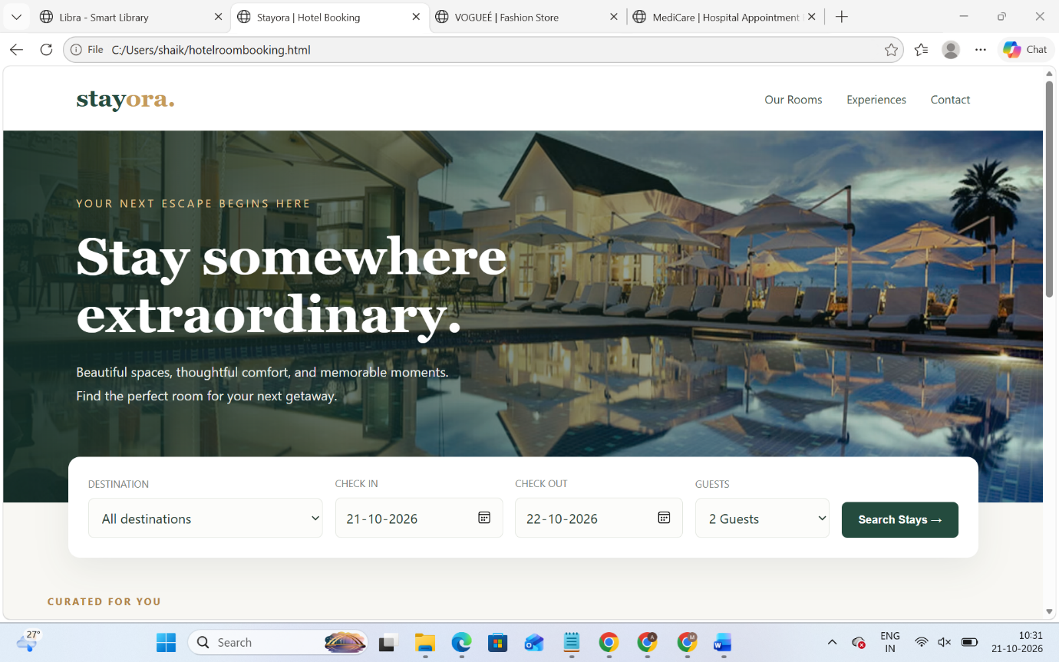
Result: Thus, the Hotel Room Booking System was developed successfully. It allows users to view room details, enter reservation information, and receive a booking confirmation through a user-friendly interface.

